Usage 1—Ты verses Вы
Russian has two words that mean “you”. The word “ты” is singular whereas the word “вы” is plural. English used to have two forms too. The word “thou” was the singular form and “you” was the plural form. Originally the singular form was used to address one person and the plural form to address a group.
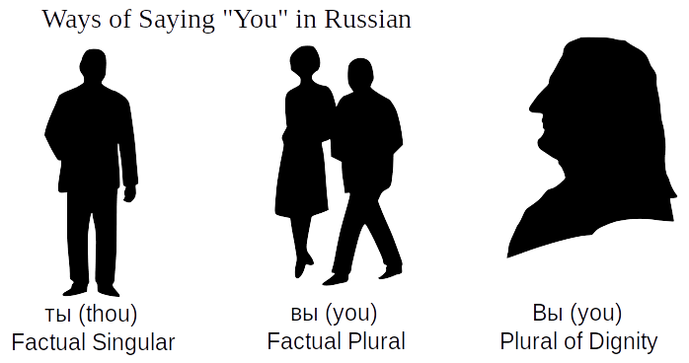
But many cultures (including English and Russian) also developed a custom of addressing important persons using the plural as a way of showing them honor. For example, servants called their masters “you” but their masters continued to call them “thou”. In English the list people worthy to be called “you” constantly expanded. By the 15th century when Shakespeare wrote it was common to call one's equals “you”. Two centuries later servants were called “you” too. Nowadays everyone is “you” and “thou” is all but forgotten.
The loss of “thou” presents a problem for English speakers learning other languages since they have never had to decide in which social situations they should say “you” rather than “thou” when speaking to just one person.
In Russian it depends on the relationship the speakers have to one another and the situation. Conversations can be divided into three broad groups in which the participants:
- Address one-another as ты (thou)
- Address one another as вы (you)
- One party addresses the other as вы, but is himself addressed as ты.

1) Symmetrical ты Relationships
- Between parents and children
- Between God and a human being (without exception)
- Between brothers and sisters, irrespective of age
- Between spiritual brothers and sisters (strong rule)
- Children among themselves (strong rule)
- Between close friends
- Between college students
- Between soldiers
- Between young adults in non-formal situations (weak rule)

2) Symmetrical Вы Relationships
- Between customer and store employee (see exception below)
- Between citizen and government official (strong rule)
- Between college students and professors

3) Asymmetrical Relationships
- Primary school teachers generally address their students as ты (particularly in the lower grades) but the students always address their teachers as вы.
- When one party is a small child and the other is an adult stranger, the child must address the adult as вы.
- An elderly customer may choose to address a much younger clerk as ты, but the clerk will still address him as вы.
As you can see, the choice of mode of address depends not only on the relative ages of the parties but also on the social situation in which they find themselves.
Using вы to address one person is roughly equivalent to calling him Mr. or Mrs. So while Mr. John Jones might say to a younger colleague “call me John”, Ivan Ivanov would say “Давайте на ты.” (Let's switch to thou.)

