Dialog 3—Чаепитие (Tea Party)
In Russian culture tea drinking is an important social activity enjoyed by both sexes. It is frequently done at the kitchen table. There will almost always be a light snack to go with the tea (к ча́ю). This might be sweets such as cookies or open-topped finger sandwiches.
See Also
- Dialog 3 Audio
- Flashcards—Dinner Table
- Flashcards—Food Items
Хозяин | Гость
Бу́дете чай?  Will you [have] tea? | Да, спаси́бо.  Yes, thank you.
Хоти́те са́хар?  Do you want sugar? | Нет, спаси́бо.  No, thank you.
Хоти́те молоко́?  Do you want milk? | Да, спаси́бо.  Yes, thank you.
Е́шьте пече́нье!  Eat a cookie! | Спаси́бо.  Thank you.
Бу́дете ещё чай?  Will you have more tea? | Нет, спаси́бо. Бы́ло очень вку́сно.  No thank you. It was very tasty.

Usage Notes
- In English it is assumed that if we say “thank you”, we accept the offer. But if we just say “спаси́бо” the hearer will not know whether we mean “yes, thank you” or “no, thank you”. That is why in the dialog we use “да, спаси́бо” to accept the offer and “нет, спаси́бо” to decline it.
- Instead of “да, спаси́бо” (yes, thank you) one may say “пожа́луйста” (if you please).

Encouragement
If you decline tea, your new friends may ask “Е́сли чай не пьёшь, отку́да си́лу берёшь?” (If you don't drink tea, how to you keep up your strength?) They are teasing you to try to get you to change your mind.

Making Tea
While nowadays Russians may use tea bags, they still frequently make tea in the traditional way. They put several spoonfuls of tea leaves in the bottom of a teapot (зава́рочный ча́йник) and pour hot water on them. They choose the proportions so as to make a tea that is much too strong for drinking. This they call “зава́рка” (the brew). When serving the tea they pour about half an inch of the brew into the teacup (ча́шка) and fill the rest up with hot water. The hot water comes from a tea kettle heated on a gas stove, an electric tea kettle, or on formal occasions from a traditional самовар which is a self-fired tea kettle with a spigot in the side for dispensing hot water.
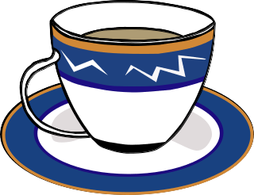  Ча́шка | 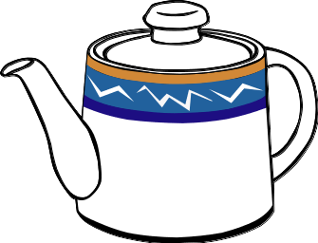  Зава́рочный ча́йник | 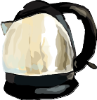  Эле́ктроча́йник | 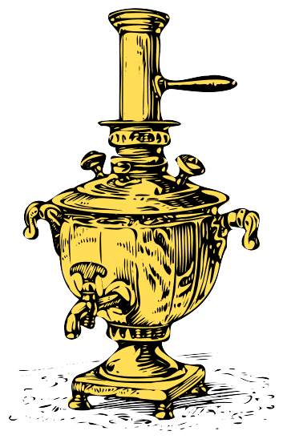  Самова́р

