Grammar 20—Telling Time
In both Russian and English we can use a variety of expressions to describe the time indicated by a clock:
See Also
- Clock with Time in Russian Words
- Vocabulary 1—Cardinal Numbers
- Vocabulary 2—Ordinal Numbers
- Grammar 5—Russian Case Charts
- We can read off the numbers shown on the dial. When we do so we are stating the number of whole hours and minutes which have passed since noon or midnight. This option is always available.
- In Russian we can state the number of minutes into the hour which is in progress. This makes sense up to the half hour.
- We can say how many minutes remain until the little hand passes the next number on the dial. This is used after the half hour.
- We can speak of quarters and halves of an hour rather than of minutes.
- If the precise time is not important, then in Russian we can say things like “at the beginning of the hour” to indicate a time close to the start of the our or “at the end of the hour” for a time near its end.
The concept of the hour in progress will be unfamiliar to most English speakers. It is important to understand that “the first hour” does not mean one o'clock. It means the sixty-minute period which starts at 12 o'clock and ends at one o'clock. In the examples below the hour in progress is represented by a shaded pie slice.
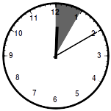 | The first hour began at 12 o'clock. To say that something happens at the time shown at left:  в двенадцать часов десять минут—at twelve hours ten minutes  в десять минут первого—at ten minutes of the first  в начале первого часа—at the beginning of the first hour
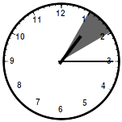 | As the little hand passes the 1 the first hour ends and the second begins. To specify this time use any of these expressions:  в час пятнадцать минут—at [one] hour fifteen minutes  в пятнадцать минут второго—at the fifteenth minute of the second [hour]  в четверть второго—at a quarter of the second hour  в начале второго часа—at the beginning of the second hour
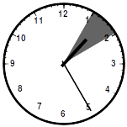 | To specify this this time:  в час двадцать пять минут—at [one] hour twenty five minutes  в двадцать пять минут второго—at twenty five minutes of the second [hour]
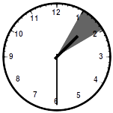 | To specify this time:  в час тридцать минут—at [one] hour thirty minutes  в половину второго—half of the second [hour]
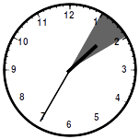 | Once the hour is half-way done we may choose to say how soon the little hand will pass the next number. To specify the time shown at left:  в час тридцать пять минут—at [one] hour thirty five minutes  без двадцати пяти два—lacking twenty five minutes to the two
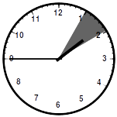 | To specify the time shown at left:  в час сорок пять минут—at [one] hour forty five minutes  без пятнадцати два—lacking fifteen to the two  без четверти два—lacking a quarter to the two
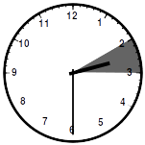 | Once two o'clock is reached we must decline the word “час” in the genitive singular:  в два часа тридцать минут—at two hours thirty minutes  в половине третьего—half of the third [hour]
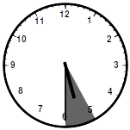 | Once five o'clock is reached we must decline the word “час” in the genitive plural:  в пять часов тридцать минут—at five hours thirty minutes  в половине шестого—half of the sixth [hour]
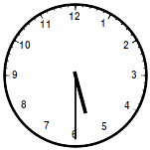 | If we have chosen to simply read the numbers off of the clock face and the time is after noon, we can use 24-hour time:  в семнадцать часов тридцать минут—at seventeen hours thirty minutes  24-hour times is frequently used in formal contexts such as railway timetables and theatrical programs. In conversation it is more common to use a 12-hour clock and one of the expressions from the charts below to indicate AM or PM.

  AM | PM
  до обеда (before lunch) | после обеда (after lunch)
  до полудня (before midday) | после полудня (after midday)
  Other Expressions for 12-Hour Time
  утра (of the [daylight] morning)
  дня (of the [middle of] the day)
  вечера (of the evening)
  ночи (of the [late] night)

